Integrated Situation:
Imagine a group of people in a city who want to grow their own food and live in a more eco-friendly way. They've started a great project – an "urban garden initiative." This is like a club or a project focused on gardening in the city.
However, right now, this initiative is like a friendly person without a name tag or a clear way to show what they're all about. They need a brand identity. As a trainee from L3 Software development Think of a brand identity as the personality and look of the initiative that will helps people to understand what company do. Make a web banner and logo looks like the following.
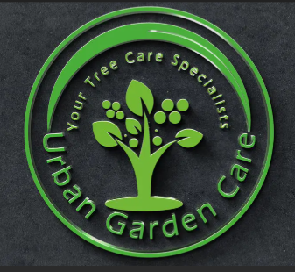


TASK TO PERFORM:
Task1: Create a Logo with “urban garden initiative” as a company name.
Task2: Create a web banner with “urban garden initiative” as a company name and insert Above Logo on it.

